Nanostructures Developed from Semi-interpenetrating Polymer Network Structures

Sachin H. Jainª, Kazutaka Murata, and Takanori Anazawa*

Kawamura Institute of Chemical Research, 631 Sakado, Sakura, Chiba 285-0078, Japan

Telephone: 43-498-2135; Fax: 43-498-2565
E-mail: takanori-anazawa@ma.dic.co.jp (T. Anazawa)

ª Current Address:
Department of Polymer Technology, Eindhoven University of Technology
Den Dolech 2, STO 0.45, P.O.Box 513, Eindhoven, The Netherlands.

Summary
Morphology development from a semi-interpenetrating polymer network structure (semi-IPN structure), induced by first-stage photocuring and aided by annealing, is investigated in a binary blend of a photocurable polymer (2,2-bis(4-(acryloxy diethoxy)phenyl)propane; BPE4) and a linear polymer (polysulfone; PSU). A blend with a miscible semi-IPN structure is produced by photocuring below the glass transition temperature (T_{g}) of the homogenous mixture of BPE4 and PSU, and is then annealed and post-cured at a higher temperature. The investigation reveals that the phase structures, which can be controlled by appropriately tuning the annealing temperature, range from BPE4-rich domain structures, through interconnected structures, to PSU-rich domain structures. The BPE4-rich domains are connected linearly to form an interconnected structure. The BPE4-rich and PSU-rich domains are restricted to the nanometer scale with sizes of less than 100 nm over almost the entire operating range of annealing temperatures and compositions. The characteristic sizes of the phase-separated structures can be varied by adjusting the degree of the cross-linking in the semi-IPN structure. The mechanical properties (tensile strength and modulus) are a maximum in the blend with the interconnected structure, due to the high conversion of BPE4 and the strong interfacial adhesion between the two phases supported by the stability of the morphology resulting from the annealing.

Keywords : annealing, nanostructure, phase separation, photopolymerization, semi-IPN
Introduction
The physical properties of multicomponent polymers are highly dependent on their phase-separated morphologies. In polymer blend systems associated with polymerization-induced phase separation, phase-separated structures can be varied, from semi-interpenetrating polymer network (semi-IPN) structures to bicontinuous and droplet structures, by tuning the blend compositions and preparation conditions.^{[1-4]} Semi-IPN structures can be obtained by curing below the glass transition temperature (T_{g}) of the blend prior to the chemical reaction.^{[1,2]} In particular, photocuring systems offer advantages over thermo-curing systems for the obtained semi-IPN structures due to their cold (independent of the temperature) and rapid cure qualities.^{[1,5-7]} The phase structures, induced by annealing from the obtained semi-IPN structures after first-stage photocross-linking, have been investigated in a miscible blend of poly(vinyl methyl ether) (PVME) and poly(styrene-stat-(chloromethyl)styrene containing anthracene moieties (PSCS). It has been reported that the phase-separated structures induced by annealing are restricted to the nanometer scale.^{[6]}
We have investigated the morphology, phase separation behavior, and mechanical properties of binary blends of photocurable and linear polymer systems, which can be further generalized and applied to systems having a reactive photocurable monomer as one of their starting components.^{[1,89]} It has been found that the mechanical properties (tensile strength and modulus) are a maximum in blends with vague domain structures, which are intermediate structures between semi-IPN and bicontinuous structures that feature a strong interfacial interaction between the two phases.^{[8,9]} On the one hand, the mechanical properties deteriorate in those blends with semi-IPN structures due to there being less conversion of the photocurable polymer, and bicontinuous phase-separated structures also have poorer properties because the interfacial interaction decreases as the degree of phase decomposition increases. In this paper, we report on the controlled development of the morphology from semi-IPN structures induced by tuned annealing of a binary blend of photocurable polymer [2,2-bis(4-(acryloxy diethoxy)phenyl)propane (BPE4)] and linear polymer [polysulfone (PSU)] systems. Moreover, the relationship between the morphologies and mechanical properties is also investigated and established.

Experimental Part
Materials
A sample of 2,2-bis(4-(acryloxy diethoxy)phenyl)propane (BPE4), supplied by Daiichi Seiyaku Kougyo Co. (Japan), was used as the photocurable monomer. The linear polymer was polysulfone (PSU, Udel P-3703) obtained from Amoco Chemicals. The supplied PSU was purified before use by precipitating it from a dichloromethane solution (ca. 2 wt.-% concentration) with an excess volume of methanol. The weight-average molecular weight (M_{w}) of the purified PSU was 44300, and the ratio between the weight-average and number-average molecular weights (Mw/Mn= polydispersity) was 1.90. A sample of 1-hydroxycyclohexyl-phenyl ketone (HCPK, Irgacure 184), obtained from Ciba Specialty Chemicals, was used as the photoinitiator. The BPE4 was augmented with 2 wt.-% (0.5 mol.-%) HCPK (BPE4/HCPK) = (98/2 w/w). The chemical structures of the photocurable monomer (BPE4), linear polymer (PSU), and photoinitiator (HCPK) are shown in Figure 1.

Preparation of Blend Films
The following describes a typical procedure for preparing a blend film. BPE4 (5 g), including 2 wt.-% of HCPK (0.1 g), and PSU (5 g) were dissolved in dichloromethane (80 g) (for 50 wt.-% PSU composition). The samples were prepared by solvent-casting on glass slides and were then kept in a petri dish overnight at room temperature (25°C). These solvent-cast films were then dried in a vacuum oven at 50°C for 3 hrs. In this study, all the coatings with 30 to 70 wt.-% PSU before the photopolymerization were transparent and homogeneous over a temperature range of –10 to 220°C. The coatings, sandwiched between two glass slides held apart with 0.15-mm spacers (PET films), were kept below T_{g0} (42°C for 50 wt.-% PSU) on a cooling stage (Nippon Blower, Japan), where T_{g0} is the glass transition temperature of a homogeneous mixture of BPE4-monomer and PSU before photoirradiation. The coatings were then irradiated with ultraviolet (UV) light for 90 s. using a high-pressure Hg-lamp (Spot Cure 250, Ushio Electric, Japan) in a nitrogen atmosphere (first-step curing). The UV intensity at the surface of the coatings was ca. 10 mW cm⁻² at 365 nm. A transparent cured blend coating with a semi-interpenetrating polymer network (semi-IPN) structure, which has one glass transition temperature, was obtained. The transparent coating was then annealed in an oven over a temperature range of 50 to 200°C for 1 hr. The annealed blend coating was then photoirradiated again (second-stage curing) over a temperature range of 25 to 200°C with a high-power UV light (3 kW metal-halide lamp, Eye graphics, Japan) with an intensity of 75 mWcm⁻² for 90 s. in a nitrogen atmosphere. The cured blend film was then obtained by removing the coating from the glass slide.

Measurements
Morphological observations were carried out by means of transmission electron microscopy (TEM) using a JEM-200CX (JEOL, Japan) and scanning electron microscopy (SEM) using an FE-SEM S-800 (Hitachi, Japan). For the TEM observations, cross sections of the specimens were cut into ultra-thin sections of ca. 50 nm by using an ultramicrotome, and were then observed without staining. The fracture surface of the broken blend film after the tensile test was observed using SEM. The fracture surface was coated with a 5-nm layer of platinum. All the micrographs, obtained using electron microscopy, were taken from the core region in the coatings (0.15 mm thickness).
The mechanical properties (tensile strength (yield strength), tensile modulus, and elongation at break) of the blend films were obtained by performing a uniaxial tensile test with an Autograph AGS-H (Shimadzu, Japan). A gauge length of 10 mm and a cross-head speed of 5 mm min⁻¹ were used. Measurements were performed at room temperature (25 ± 1°C) with film specimens measuring (5 × 50 ×  0.15 mm³).
The extent of the curing of BPE4 in the blends was estimated by Fourier-transform infrared spectroscopy (FT-IR) using an FT-IR-550 (JSCO, Japan). Conversions were calculated from the area [(A₈₀₅)_{before} and (A₈₀₅)_{ir}] of absorption of the reactive acrylate functional groups at 805 cm⁻¹ (CH₂ = CH twisting) in the blends both before and after photoirradiation, respectively.^{[10]} The conversion (Rc (%)) of BPE4 is given by [1-(A₈₀₅/A₁₇₃₂)_{ir}/(A₈₀₅/A₁₇₃₂)_{before}] ×  100, where (A₁₇₃₂)_{before} and (A₁₇₃₂)_{ir} are the areas of the absorption of the non-reactive ester functional groups at 1732 cm⁻¹ (C = O stretching) in the blends before and after photoirradiation, respectively. The FT-IR spectra of the blends were measured by using the KBr method.
The glass transition temperatures (T_{g}) of the resulting blend films were measured using a dynamic viscoelastometer with a Solid Analyzer RSA-II (Rheometric Scientific, Inc.). The complex modulus E* was measured at 1 Hz over a temperature sweep of 0 to 200°C at a heating rate of 2°C min⁻¹. The T_{g} values of the blend films refer to the maximum at the tan δ (=E”/E’) peak, where E’ is the storage modulus and E” is the loss modulus.
The T_{g}s values for the blend coatings both with and without the first-step curing were obtained using a differential scanning calorimeter (DSC) at a heat scan rate of 10°C min⁻¹ in a nitrogen atmosphere using a DSC-7 (Perkin Elmer).

Results and Discussion

Morphology Development from Semi-IPN Structure Induced by Annealing
A transparent blend coating with a 50 wt.-% PSU and having a miscible semi-IPN structure was prepared at 22°C by means of photoirradiation at 10 mW cm⁻² for 90 s. in a nitrogen atmosphere. This coating exhibited one T_{g} at 58°C, and was annealed at a temperature of 80 to 200°C for 1 hr. Furthermore, the annealed blend coating was photoirradiated again at 150°C with UV light with an intensity of 75 mW cm⁻² for 90 s in a nitrogen atmosphere.
TEM observation revealed phase-separated structures in those blends annealed above 80°C, which is a higher temperature than T_{g} (58°C) for the blend with the miscible semi-IPN structure obtained after the first-step curing. The morphologies of the resulting blends annealed at 80°C, 150°C, and 200°C are shown in Figure 2 (TEM images). In the TEM images, the dark part is the PSU-rich phase, while the light part is the BPE4-rich phase.
In the blend annealed at 80°C, the BPE4-rich phase formed small spherical domains with a size of 30 to 50 nm that were dispersed throughout the PSU-rich matrix phase. The phase boundaries between the BPE4-rich and PSU-rich phases were diffused. The BPE4-rich domain structures were obtained in the blends annealed at temperatures between 80 and 110°C. An interconnected morphology appeared in the blend annealed at 150°C. The BPE4-rich domains with a size of 30 to 50 nm were connected linearly in the PSU-rich matrix where they formed an interconnected structure, the characteristic length of which was less than 0.1 μm. This produced a nanometer-scale phase-separated structure. This interconnected structure is the reverse of the phase-separated structures that appear in those blends prepared using only phase separation that is induced by polymerization (without annealing), in which the PSU-rich phase appears as a network-like continuous phase.^{[1]} The phase boundaries between the two phases were also diffused. The diffusion phase boundary should provide a strong interfacial interaction between the BPE4-rich and PSU-rich phases. The interconnected morphologies were formed in the blends with 50 wt.-% PSU as a result of annealing between 120 and 170°C. A droplet-like morphology appeared in the blends annealed at 200°C. The PSU-rich phase exhibited small spherical domains with a size of 20 to 80 nm, dispersed as islands within the BPE4-rich matrix, which is the reverse of the structure of the blend annealed at 80°C. The phase boundaries between the PSU-rich domain and the BPE4-rich matrix phases were found to be sharp. It is notable that the PSU-rich domains maintained a size of 20 to 80 nm regardless of the annealing temperature. The phase separation should be restricted by the three-dimensional cross-linking network formation.
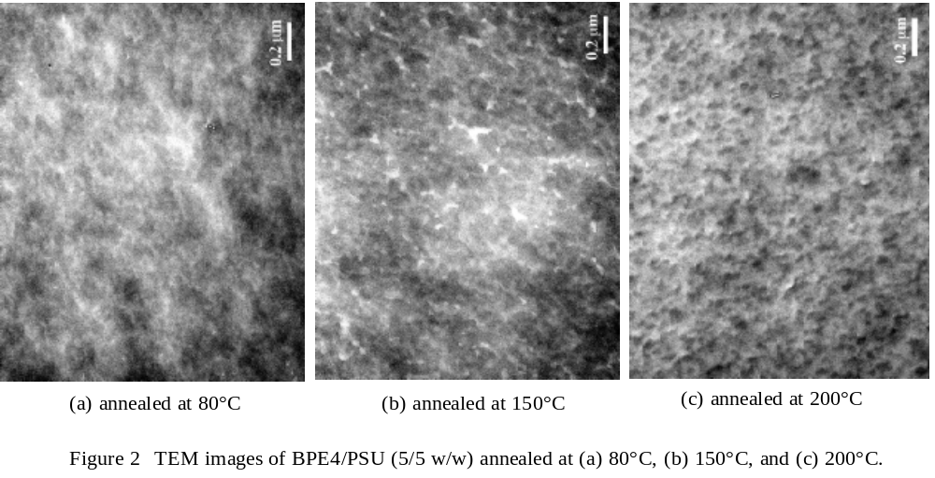

Figure 3 shows the temperature dependence of tan δ for the resulting blends with 50 wt.-% PSU annealed at 80 to 200°C. Two distinct peaks appear on the tan δ curves. The peak that appears at around 80 to 100°C corresponds to T_{g} of the BPE4-rich phase, while that which appears at around 160°C corresponds to T_{g} of the PSU-rich phase. The composition of the PSU-rich phase was found to be (BPE4/PSU) = (28/72 w/w), as calculated from the Fox relationship^{[11]}, where T_{g}s for pure BPE4 (cured) and PSU were 86 and 198°C, respectively. The extent of the phase decomposition in the PSU-rich phase was independent of the annealing temperatures, by which the three types of the phase morphologies were obtained. The tan δ curve for the blend annealed at 80°C shifted slightly to the lower temperature region. This can be attributed to the lower conversion of BPE4, which is shown in Figure 4. The conversion of BPE4 increased from 52% to 88% with the annealing temperature up to 100°C, and then became saturated at around 90% with annealing to more than 120°C. The tan δ curves for 120°C and 150°C coincide with the peaks. The droplet structures in the PSU-rich phase appeared in those blends annealed above 180°C, which is higher than T_{g} of the PSU-rich phase (160°C). The PSU coalesces in the blend as a result of annealing above T_{g}. In the blend annealed at 200°C, the low-temperature peak (86°C) shifted slightly to the lower-temperature region, while the high-temperature peak remained at 160°C. This can be ascribed to the increase in the degree of phase separation in the BPE4-rich phase. The T_{g} shift also points to the PSU coalescing from the BPE4-rich phase due to heating of the PSU-rich phase to above T_{g}. The shifted tan δ peak corresponds closely to that of the pure BPE4 (86°C).

The BPE4-rich domain structures are obtained as a result of the coalescing and cross-linking of the unreactive BPE4 part through lower-temperature annealing. The number of coalescing BPE4 molecules increases with the annealing temperature. The interconnected structures develop from the BPE4-rich domain structure by increasing linearly the size of the domain, in which two or three links connecting the coalesced domains are retained. In other words, a partially broken cross-linking network of BPE4 is coarsened to the interconnected morphology by the coalescence of the unreactive BPE4.
Figure 5 is a schematic of the three types of phase structures of the BPE4-domain structures (region II), the interconnected structures (region III), and the PSU-rich domain structures (region IV), which were developed from a semi-IPN structure by annealing, as a function of their composition. The first-step curing temperatures were -5°C for 30 wt.-%, 0°C for 40 wt.-%, 22°C for 50 wt.-%, and 25°C for 60 to 70 wt.-% PSU, all of which are below T_{g0}s. The second-step curing processes were performed at the same temperatures as the annealing processes. T_{g(PSU)}s and T_{g(1st)}s are also shown in Figure 6, where T_{g(PSU)} is T_{g} of the PSU-rich phase in the resulting blend film and T_{g(1st)} is T_{g} of the blend with the miscible semi-IPN structure obtained after the first-step curing. The boundary annealing temperature (T_{BP}) for the PSU-rich domain structure increased with the PSU composition, which corresponds closely to T_{g(PSU)}s + 15°C. In contrast, the boundary annealing temperature (T_{BB}) for the BPE4-rich domain structure reached a minimum at around 40 to 50 wt.-% PSU. The increases in T_{BB}s for the blends with more than 50 wt.-% PSU correspond closely to T_{g(1st)}s + 20°C. The value of T_{BB}s increased as the PSU composition decreased in the blends with less than 50 wt.-% PSU. The BPE4-rich domain structures appeared in region II. It is worth noting that the domains of the BPE4-rich and PSU-rich phases could be held to the nanometer scale (below 100 nm) independently of not only the annealing conditions but also the compositions. The semi-IPN structures appear to localize the diffusion of the molecules.
The interconnected structures were attained in the intermediate annealing temperature region (region III) between the preparation temperatures of the BPE4-rich and PSU-rich domain structures. In the cases of the BPE4-rich domain structure and the interconnected structure, the phase boundaries between the BPE4-rich domain and the PSU-rich matrix are diffused, which would bring about the strong interfacial adhesion.
TEM examination does not reveal phase structures in those blends annealed below T_{BB}s. Miscible semi-IPN structures are formed in those blends annealed below T_{g(1st)}s (region I_{a}), while phase-separated semi-IPN structures are obtained by annealing at an intermediate temperature (region I_{b}) of T_{g(1st)}-T_{BB}.

Dependence of First-Step Curing on Morphology
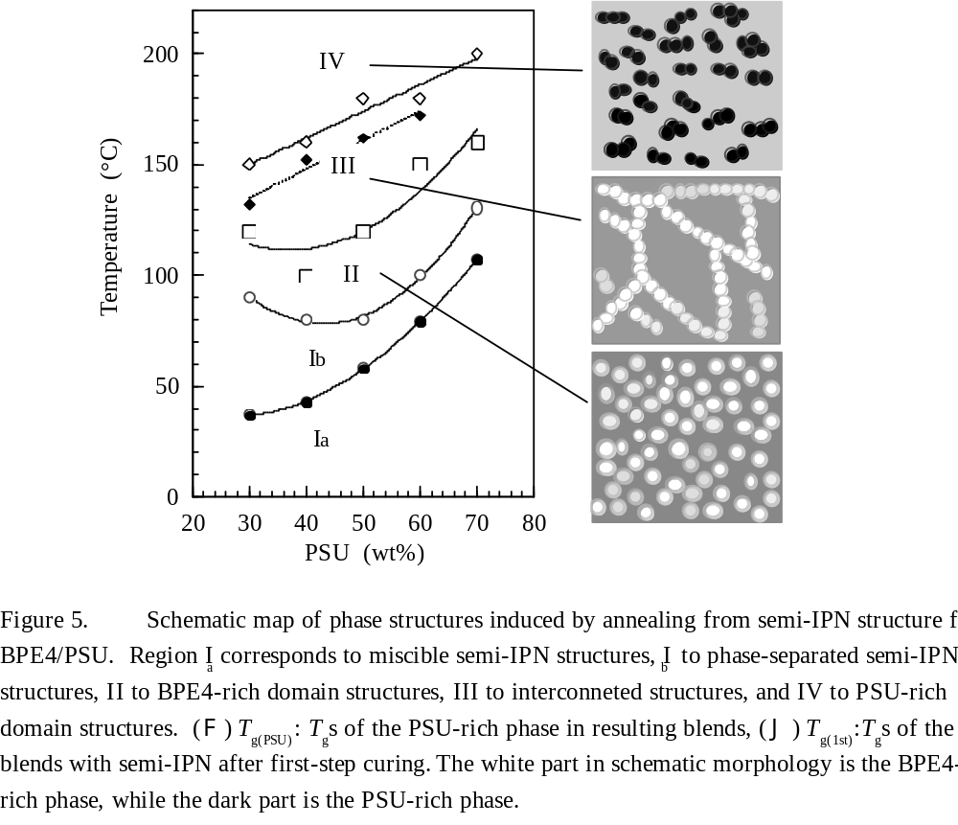
The degree of cross-linking in the semi-IPN structure can be controlled by adjusting the photocuring temperature or the light intensity in the first-step curing. We investigated the effect of the amount of cross-linking on the resulting morphology by controlling the cure temperature. Figure 6 shows BPE4 conversion in those blends with 50 wt.-% PSU after first-step curing before annealing and post-curing. The degree of BPE4 conversion gradually increases with the cure temperature. This conversion should correspond to the degree of cross-linking of BPE4, which relates to the restriction on the phase decomposition. Figure 7 shows the phase-separated structures prepared at the first curing temperatures of 0 and 30°C, which are below T_{g0} (42°C). The annealing and post-curing were performed at 150°C. Interconnected structures were also obtained with the blends cured at 0°C and 30°C. The BPE4-rich phase appeared as a network-like phase in the PSU-rich matrix phase. The BPE4-rich domains, which are the same diameter as the network-like phase, became larger as the first-step curing temperature is reduced, as shown in Figure 8. The domain size fell from 0.1 μm to 40 nm as the first-step curing temperature was increased from 0°C to 30°C, and then saturated at around 40 nm up to 30°C of the first-step curing temperature. In the TEM image, the characteristic length scales of the interconnected structures were also observed to increase with the drop in the first-step curing temperature. The characteristic length scale in the blend cured at 0°C was 0.3 to 0.5 μm, a reduction of 0.1 to 0.2 μm, 0.08 to 0.13 μm, and 0.06 to 0.1 μm as the first-step cure temperature was increased by 10°C, 22°C, and 30°C, respectively. The transparency of the blend films fell to below 70% (0.15-mm thick) in those blends cured below 10°C. The characteristic length and domain size were strongly affected by the amount of cross-linking in the semi-IPN structure, which can be controlled easily by adjusting the first-step curing temperature and light intensity. It has been reported that the phase morphology also varies with the amount of anthracene moieties in PVME/PSCS system.^{[6]}

Improvement of Mechanical Properties by Annealing
There were no improvements in the mechanical properties of those blends with semi-IPN structures and lower conversion rates of photocurable polymers.^{[8,9]} In cured diacrylate and polycarbonate systems, the mechanical properties of the blend with a miscible semi-IPN structure were improved by annealing and post-curing at high temperatures.^{[9]} We also tried to improve the mechanical properties of the blends with 50 wt.-% PSU having a semi-IPN structure by increasing the conversion rate of the BPE4 by annealing and post-photocuring at high temperatures. The first- and second-step curing were performed at 22°C and 150°C, respectively, the same temperatures as those used for morphological investigations.
Figure 9 shows the effect of the annealing temperature on the tensile strength, tensile modulus and elongation upon breakage of the resulting blend films. The resulting blend films were transparent (> 85%), regardless of the annealing temperatures (80 to 200°C). The tensile strength and modulus reached a maximum when annealing was performed at around 150°C. The maximum strength (74 MPa) was almost double that (37 MPa) of the blend with the semi-IPN structure (see Table 1), which was prepared with no annealing and with post-photocuring at 25°C for 90 s at a light intensity of 75 mW cm⁻². The maximum strength was almost the same as that (73 MPa) of the blend photopolymerized at the optimum cure temperature (120°C).^{[8]} The maximum modulus (1.75 GPa) was ca. 1.6 times higher than that of the blend with the semi-IPN structure (1.1 GPa). However, the maximum modulus was ca. 20% lower than that of the blend photopolymerized at the optimum cure temperature (2.1 GPa). The elongation upon breakage gradually deteriorated from 20% to 14% with the increase in the annealing temperature.

The rate of conversion increased from 52% to more than 90% as the annealing temperature was increased up to 120°C, with the rate of conversion saturating at 90%, as shown in Figure 4. The small improvements in the strength and modulus obtained with annealing below 100°C can be attributed to the lower rate of conversion of BPE4 in spite of the good interfacial adhesion observed by electron microscopy. The dependence of the strength and modulus on the annealing temperature below 100 to 120°C corresponds closely to that of the conversion. An improvement in the mechanical properties above 120°C will be realized by the morphological differences induced by annealing. The maximum strength and modulus are obtained with the blend having a nanometer-scale interconnected structure. The drastic degradation in the mechanical properties observed in those blends annealed above 180°C results not only from the isolated formation of a PSU-rich phase, which acts as a reinforcing component, but also from the deterioration in the interfacial adhesion.
The fracture surfaces of the broken blends after the tensile tests were observed using SEM. The results are shown in Figure 10. The fracture surface of the blend annealed at 80°C appeared soft and weak. The SEM image supports the theory that the degree of curing is insufficient. The fracture surface of the blend annealed at 150°C exhibited ductile fracture behavior, while that annealed at 200°C exhibited brittle fracture behavior. At 150°C, the blend matrix was stretched and included small BPE4-rich domains. The SEM image reveals that the BPE4-rich domains are integrated into the PSU-rich matrix with strong interfacial adhesion, which corresponds closely to the TEM image (Figure 2b) of the interconnected structure with a diffusion phase boundary. At 200°C, the interfacial interaction between the two phases appears to decrease as the annealing temperature rises with the increase in the extent of the phase decomposition.
In the blends with 30 to 70 wt.-% PSU, the dependence of the tensile strength and modulus on the annealing temperature also provided the optimum conditions, which are listed in Table 1. The mechanical properties of the non-annealed films, which were photopolymerized at 25°C for 90 s with a light intensity of 75 mW cm⁻², are also listed in Table 1. The optimum annealing temperature increases with the PSU content, and corresponds closely to ca. T_{g0} + 100°C and ca. T_{g(1st)} + 80°C of homogenous mixtures with and without first-step curing, respectively. The maximum properties were also obtained with those blends having interconnected structures independent of the composition shown in Figure 5. The maximum strength, reached at around 60 wt.-% PSU, was more than double that of the blend with a semi-IPN structure, while the maximum modulus, which was 1.5 times higher than that of the semi-IPN blend, was obtained with the blend with 40 wt.-% PSU. These maximum properties (76 MPa and 1.8 GPa) were almost the same as those obtained with the neat PSU.

It appears that the mechanical properties of blends with semi-IPN structures can be improved by annealing and post-photocuring at high temperatures. The resulting blends retained their transparency. However, it was found that the optimum annealing procedure turned the semi-IPN morphologies into interconnected structures.
Table 1 Mechanical Properties Obtained with Optimum Annealing Conditions

Conclusions
Local phase separation from a semi-IPN structure is induced by annealing. The phase structures are restricted to the nanometer scale by cross-linking with the network in the semi-IPN structure. The characteristic size of the resulting structure can be controlled by the amount of cross-linking. The phase structure can be varied from a semi-IPN structure to a BPE4-rich domain structure, while interconnected structures and PSU-rich domain structures can be obtained by adjusting the annealing temperature. PSU-rich domain structures were obtained by annealing above T_{g(PSU)}s. Interconnected structures were formed by the linear connection of the BPE4-rich domains in the PSU-rich matrix. Excellent improvements in the mechanical properties are presented in the blends with an interconnected structure having a nanometer scale with sufficient curing and a strong interfacial interaction between the two phases.

Acknowledgments. We thank the Analysis Center of Dainippon Ink and Chemicals, Inc., for their support. We also thank Dr. M. Uemura, Dr. S. Matsumoto, Dr. N. Hayashi, and Mrs. R. Kimura of Dainippon Ink and Chemicals, Inc., for their discussions and advice regarding the experimental measurements. We would also like to thank Dr. K. Haraguchi and Dr. A. Teramae of The Kawamura Institute of Chemical Research for their helpful discussions and advice.

References
[1] K. Murata, S. Jain, H. Etori, T. Anazawa, Polymer 2002, 43, 2845.
[2] B. J. P. Jansen, H. E. H. Meijer, P. J. Lemstra, Polymer 1999, 40, 2917.
[3] T. Inoue, Prog. Polym. Sci. 1995, 20, 119.
[4] B. J. P. Jansen, S. Rastogi, H. E. H. Meijer, P. J. Lemstra, Macromolecules 1999, 32, 6290.
[5] Q. Tran-Cong, “Structure and Properties of Multiphase Polymeric Materials,” Marcel Dekker Inc., New York 1998, Chapter 6.
[6] T. Tamai, A. Imagawa, Q. Tran-Cong, Macromolecules 1994, 27, 7486.
[7] K. Kataoka, A. Harada, T. Tamai, Q. Tran-Cong, J. Polym. Sci. B. Polym. Phys. 1998, 36, 455.
[8] K. Murata, T. Anazawa, to be published.
[9] K. Murata, A. Amamiya, T. Anazawa, to be published.
[10] C. Decker, Prog. Polym. Sci. 1996, 21, 593.
[11] T. B. fox, Bull. Am. Phys. Soc. 1956, 1, 123.

Figure 1 Chemical structures of BPE4, PSU, and HCPK.
Figure 2 TEM images of BPE4/PSU (5/5 w/w) annealed at (a) 80°C, (b) 150°C, and (c) 200°C.
Figure 3 Temperature dependence of tan δ for BPE4/PSU (5/5 w/w) annealed at (G) 80°C, (E) 120°C, (C) 150°C, and (A) 200°C.
Figure 4 Effect of annealing temperature on conversion of BPE4 in the resulting blend with 50 wt.-% PSU.
Figure 5 Schematic map of phase structures induced by annealing from semi-IPN structure for BPE4/PSU. Region I_{a} corresponds to miscible semi-IPN structures, I_{b} to phase-separated semi-IPN structures, II to BPE4-rich domain structures, III to interconnected structures, and IV to PSU-rich domain structures. (F) T_{g(PSU)}: T_{g}s of the PSU-rich phase in resulting blends and (B) T_{g(1st)}: T_{g}s of the blends with semi-IPN after first-step curing. The white part in the schematic morphology is the BPE4-rich phase, while the dark part is the PSU-rich phase.
Figure 6 Conversion of BPE4 in blends with 50 wt.-% PSU after first-step curing.
Figure 7 TEM images of resulting blends with 50 wt.-% PSU. First-step curing temperatures are (a) 0°C and (b) 30°C.
Figure 8 BPE4-rich domain size as a function of first-step curing temperature.
Figure 9 Effect of annealing temperature on (a) tensile strength, (b) tensile modulus, and (c) elongation upon breakage for BPE4/PSU (5/5 w/w).
Figure 10 SEM images of fracture surface after tensile test for BPE4/PSU (5/5 w/w) annealed at (a) 80°C, (b) 150°C, and (c) 200°C.

Table 1 Mechanical Properties Obtained with Optimum Annealing Conditions.
Short text
Morphology development induced by annealing from a semi-IPN is investigated in a polymer blend of photocurable diacrylate (BPE4)/polysulfide (PSU). The phase structures with nanometer scale range from BPE4-domain structures, through interconnected structures, to PSU-rich domain structures turning annealing temperature. Excellent improvements in the mechanical properties are presented in the blends with an interconnected structure due to a strong interfacial interaction between the two phases.

